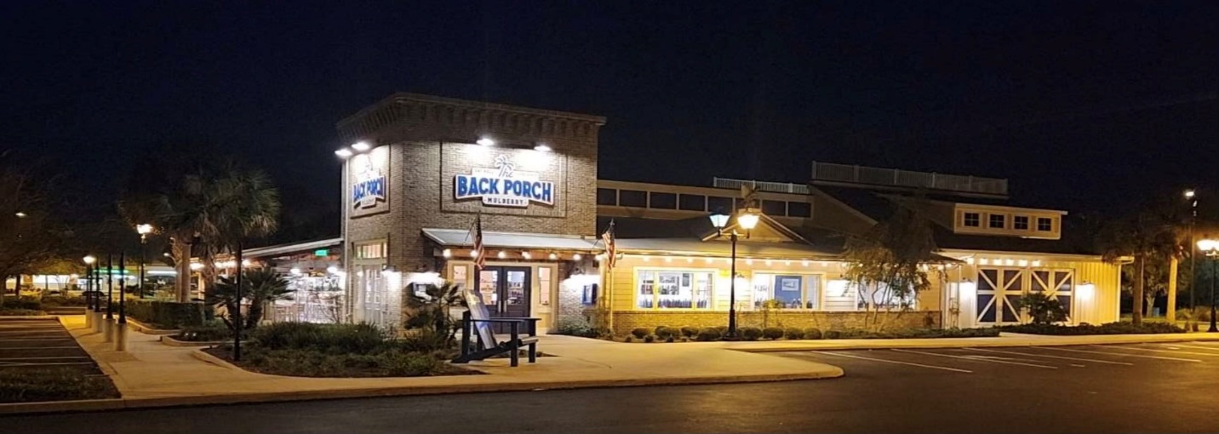

**Castleberry Ladies Luncheon**



**Date:** Monday, October 21

**Time:** 12 noon

**Location:** Back Porch Restaurant Mulberry

**Address:** 8761 SE 165th Mulberry Lane

**Hosts:** Mary Jones & Suzanne Rydel

**Let’s get in the mood for Halloween!**

**Wear your best Halloween Black and Orange or Halloween hat.**

**See you there! **